A.Ramesh Babu K.V.Acharya
Joint Convener Joint Convener,
Flat No 1103, Block 3B, J-208 Vijay Rattan Vihar,
S.M.R. Vinay Fountainhead, Sector 15, Part II,
Culvary Temple Road, Gurugram -122001
Hyderabad 500 049 Mobile: 09868220338
Mobile: 09849381995 E-mail: acharyavedavyasa46@gmail.com
E-mail: babu2609@gmail.com
__________________________________________________________________________________
Circular No. 011/2017 Dated: 03.08.2017

Dear Comrades,

LATEST UPDATE ON PENDING ISSUES OF PENSIONERS AND RETIREES

We have been posting you with the developments and various efforts put in by CBPRO and its constituents in regard to the following major outstanding issues concerning the pensioners and retirees:

- 100% DA neutralization to pre 2002 retirees;
- Improvement in family pension;
- Pension updation
- Improvement in medical insurance policy/medical benefit scheme for retirees;
- Second option to left out compulsorily retired officers;
- Second option to resignees who have put in pensionable service;

We are happy to note that due to our persistent follow up and interactions with the UFBU, they have taken up the issues mentioned in the record note of the last Bi-partite settlement during their ongoing negotiations for the 11th Bipartite Settlement. We are in constant touch with the Convenor of the UFBU and the leaders of the constituents of the UBFU. During their meeting with the Chairman of the Sub-Committee of IBA In-charge of negotiation on 1st August 2017, they have taken up the matter of 100% DA neutralization and family pension and have got a positive response from the Chairman of the sub-committee in resolving the above issues. We hope that the issues contained in the record note will be sorted out on a priority basis before the conclusion of the ensuing Bipartite Settlement as the record note is the product of last settlement.

Meanwhile we have been pursuing all the major issues concerning the retirees cited above with the Government and the IBA by writing to them and also by meeting them. After our meeting with Shri Arun Jaitleyji, Honourable Finance Minister on 1st June 2017, we are enthused by his response to us while discussing our issues. We explained to him the details about 100% DA neutralization issue, family pension and updation. By all means it was not a meeting for merely submitting a memorandum but a meeting where he heard our issues patiently asking us to clarify points in respect of the issues.

As a further follow up we met Shri Santosh Kumar Gangwarji, Honourable Minister of State for Finance on 24th July 2017 and further explained to him about our meeting with the Honourable Finance Minister and also urged him to advise his Ministry to initiate steps to resolve the issues on an urgent note as quite a lot of retirees are in their advanced age of life. The Honourable Minister was very sympathetic and assured us of the resolution of the pending matters. He also informed us that he had already talked to the Ministry officials in this regard and assured of reminding them further.

In between the meetings we had with the Honourable Finance Minister and Honourable Minister of State for Finance, we were also pursuing the issues on a continuous basis with the top Ministry officials in the Department of Financial Services, Ministry of Finance. We have given a detailed note on 17th July 2017 in respect of all the above issues and also submitted a chart with approximate calculations in regard to each of the above issues. We have also mentioned in our note that the cost implications are not going to affect the profitability of the Banks as the payments have to be made out of Pension Funds which are adequate to meet the cost of improvements.

We are happy to inform you that consequent to our meetings with the Honourable Ministers, followed by meetings and discussions with the top Ministry officials, a committee has been constituted in the Department of Financial Services, Ministry of Finance to resolve the pending issues of Bank pensioners and retirees. We are hopeful of a favourable outcome in regard to the issues very shortly.

We firmly believe that the issues like Pension Updation, Family Pension, Medical Benefit Scheme etc. shall be of direct concern to the serving employees as well in the years to come on their retirement. It is imperative that the UBFU and CBPRO enhance their combined efforts for resolution of the pending issues. We are happy that all the constituents and leaders of UFBU are making sincere efforts in this regard.

Comrades, we do understand the anxiety of all concerned as the issues did not get encouraging response from any of the authorities earlier. Nevertheless we did not allow our determination to diminish for clinching the issues. The developments during the last couple of months tend to give us confidence that as a result of our efforts with Ministry and IBA and also the initiatives taken by UFBU we are inching towards a satisfactory solution to the issues raised by us. We will further step up the momentum of our efforts with the Ministry and IBA and also scale up the level of our interaction with UFBU leaders so as to ensure early success.

With regards,

Yours comradely

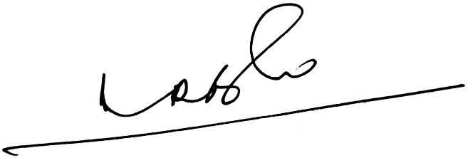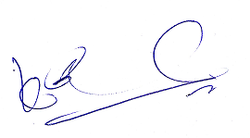
(A.RAMESH BABU) (K.V. ACHARYA)
JOINT CONVENERS

